¹Peddi Ramreddy,  ²Dr. D. Ramakrishna Reddy |   Implementation of a Dstatcom for Improving of Power Quality in the Local Distribution Grid by Using Fuzzy Logic Based Svpwm Technique
Abstract
The integration of renewable energy sources results in an increase in balancing corporate and industry load, which presents a number of power quality issues in the current environment. Highly sensitive, linear, non-linear, or imbalanced loads among grid-connected commercial utilities are among the demands operated by hospitals. The priority and diversity of these loads also result in significant issues with the quality of electricity within a distribution system for the neighborhood. Its broad divergence causes the injection of harmonics or reactive power imbalance. To address reactive electrical inequalities, neutral current reimbursement, load balancing, and harmonic abatement, the use of Distribution Static Comp (DSTATCOM) is suggested. The current study intends to improve the quality of electricity in the City Distributed Grid by generating pulses of switching during IGBT switching at the DSTATCOM using an Irregular Type-2 Fuzzy Logical Controllers (IT2FLC) equipped with a Recurrent Least Square ( ) filter. In regard to harmonic reduction, the suggested approach performs better than the Type 1 fuzzy algorithm controller and the Conventional PI controller. The suggested system is simulated using MATLAB software for efficient implementation. However, this proposed method has not looked at the first order, second order, or fifth order harmonics. Consequently, even if the system's efficiency will rise, we can say that the fuzzy in SV PWM technique is what's causing the system to perform better.
Keywords: DSTATCOM , IGBT , MATLAB , RLS , SV PWM.
1.INTRODUCTION
Systems for distributing electricity are intended to function at specific, sinusoidal voltage and current levels [1]. The rising use of non-linear load caused by the The deployment of new technology poses a serious threat to power quality. The system is regularly stressed by non-linear loads, which raises the possibility of harm to the equipment, current flowing through power loss, overheating, aberrations in current or voltage waveforms, and neutral conducting materials [2]. To run their loads more efficiently, healthcare facilities generally require high-quality electricity [3]. Nonetheless, a variety of load concentrations are present in these medical institutions, including light, hefty, balanced, non-linear, and balanced models.
Moreover, the vast majority all them are sensitive and subject to digital regulation [4]. It is not advisable to make the conventional trade-off between control and operation. Switch Multifunctional Power Supplies (SMPS) are necessary for digital load control because they are less susceptible to high power quality.
1Department of Electrical and Electronics Engineering, Chaitanya (Deemed to be University)
Near Chilukuri Balaji temple Himayatnagar, Telangana. Pin code: 500075
2Department of Electrical and Electronics Engineering, Kamala Institute of Technology and Science, Huzurabad, Karimnagar, 505468, Telangana, India
*Corresponding author E-Mail id: ramakrishnareddy_eee@chaitanya.edu.in
Heavy loads from equipment in medical centers (ICU) and medical units (CCU), lighting loads in surgical suites, and X-ray machines and CT and MRI scanning machines are examples of major power polluters [5]. These loads need to run due to their extraordinary sensitivity because disconnecting it could be dangerous or even fatal [6].
0Voltage dips and rises when switching loads because most loads linked by commercial utilities are hefty and inductive. Custom Energy Devices (CPDs) can help reduce these issues with power quality [7]. Power quality can be increased at the point of common coupling (PCC) by introducing either voltage or current, or both, in the system [8]. This results in controlled terminal voltage, which raises the power factor. There are various types of CPDs available, such as Distribution Stable Compensating Device (DSTATCOM), Dynamic Volt Restorer (DVR), and others [9]. DSTATCOM adds the necessary reactive power, increasing performance and reliability. The DSTATCOM provides better support for voltage during the sudden removal of high loads when compared alongside other CPDs and SVC. The DSTATCOM precisely adjusts its output current, irrespective of the AC system voltage, within a non-linear operational range [10]. Batteries, big capacitors, and fuel cells (FC) are a few energy storage devices which DSTATCOM can interface with and function with successfully. The DSTATCOM interaction with FC is described in [11] and is recommended. For DSTATCOM, a variety of control methods are available, and [12] discusses their topologies. Immediate Symmetry Component Theory (ISCT), Asynchronous Reference Frame Theory (SRFT), and Immediate Reactivity Power Theory (IRPT) are the three most commonly applied theories. In [13], the control process with a coupled observer is described. In [14], the current in neutral compensation is managed by combining the Euclidean Directional Search method (EDST) for VSC control with a zig-zag transformer. This functional contraction oriented around artificial neural network technology (ChANN) technique was presented in [15] as a development of ANN.
Controllers other than traditional PI controllers were utilized for efficient DSTATCOM control. Artificial intelligence controls, such as a Fuzzy Logic Control (FLC) and the Artificial Neural Network (ANN) controller, which are detailed in [16], [17], et [18], are used to compare the THD values with the PI controller. The suggested Interval IT2FLC, when compared to the AI controllers mentioned above [19], [20], can handle uncertainty more well as Type-1 Fuzzy Training Controller (T1FLC). The IT2FLC function of membership are represented by the period with Under (U) & Lower (L) functions. Thus, the uncertain data are constrained by an interval. Compared to other synthetic intelligent systems, this aids in producing correct output [21] _[23]. Little THD could be attained since IT2FLC offers accurate system control [24], [25].
Three important contributions for our work are noteworthy: a thorough simulation analysis comparing the power quality of the neighborhood distribution grid (LDG) with and without the suggested DSTATCOM setup. RLS design improved LDG power quality; eventually, DSTATCOM and IT2FLC were constructed.
Fuzzy Logic Controller-Based DSTATCOM Implementation for Distribution Systems Power Quality Improvement The CC-BY license is in effect for this article. This article can be accessed freely and is shared with the Creative Commons Authorization, which allows for unfettered distribution, use, and copying in any format as long as the original Edited July 12, 2022; approved July 7, 2022; published July 10, 2022This study proposes the use of fuzzy logic controllers (FLCs) to improve power quality (PQ) in power distribution networks. Due to non-linearity with dynamic changes in the connected loads, PQ is the main problem in the power distribution system. The suggested method improves distribution systems' power quality by using FLC to generate switching pulses for IGBT STATCOM.
By employing the suggested FLC topology, this study work also demonstrates improved performance in terms of harmonics over traditional PI controllers. To ensure successful realization, Matlab/Simulink software is used to simulate the proposed system. Fuzzy Logic Controller (FLC), Power Quality Voltage Source Inverter, STATCOM, and PI controller. Nowadays, the main source of electricity is thought to be renewable energy resources; nevertheless, excessive use of these resources will cause environmental problems and the extinction of fossil fuels. This could potentially result in distribution system problems with power quality. Power to the distribution systems is therefore taken into consideration from the in order to overcome this. As was shown in many of the applications of FACTS devices, such as voltage stabilization, energy utilization, harmonic content minimization, and PQ-related issue correction are used. A few examples of these applications known as reactive power compensation, voltage regulation, and power loss reduction are shown in [26] Meanwhile, RES FACTS devices were invented, and the specific function of PE (power electronic) converters gained popularity for protecting the grid. designed to improve the resources associated with power systems' efficiency [27]. The original research work from 2022 is required for the free distribution, use, and reproduction of this open access article, which presents D-STATCOM based on a fuzzy logic controller (FLC) for improving power quality (PQ) in power distribution networks. The coupled loads exhibit dynamic variations and linearity in power distribution. The suggested method improves distribution systems' power quality by using FLC to generate switching pulses for IGBT STATCOM. By utilizing the suggested FLC architecture, this research project additionally demonstrates improved performance in harmonic mitigation over traditional PI controllers.
Power Quality is simulated for the proposed system, including energy consumption, harmonic content abatement, voltage stabilization, and PQ-related problem solving. Additional applications include reactive power compensation, voltage regulation, and decrease of Meanwhile, RES and PE (power electronic) converters have become more well-known for their unique role in protecting the grid [28].FACTS devices first appeared in the 1980s. The purpose of FACTS is to increase the resources' efficiency. This will use the following factors to alter the harmonics:
The power converters release smoke in Vol. 10 Is Sue3, July–Sep 2022, pp. 01–09. It should be noted, nevertheless, that further, stricter limits might be specified by the system operator. To reduce harmonic output, passive filters are frequently used [29]. Modulation and converter control are two further methods that can affect the generation of harmonics. To do this, one method is to apply a selective harmonic compensation algorithm. Due to the increased susceptibility of the voltage to harmonics and other disturbances, these tactics are receiving attention when utilizing a weak grid converter [9]. For the power system to function as efficiently as possible, reactive power flow in the network must be controlled. A few fact-based components, such as the UPQC (Unified Power Quality Conditioner), SVC (Static VAR Compensator), and D-STATCOM (Distribution Static Var Compensator), will adjust the reactive power flow. Additionally, this device has the ability to regulate the line impedance, voltage, and angle among the phases as they go from the transmitting end to the receiving end [10]. When using and managing power system analysis, the combination of data devices and power electronic converters is becoming increasingly significant.
As suggested in [30], the planning, execution, and computation will result in the identification of a power flow solution inside the power network. Nonetheless, there has previously been a lot of discussion on the impact of D-STATCOM modelling on PQ issues. This will reduce issues related to loads, control voltage at the distribution side, and mitigate voltage swings. The DSTATCOM can also be described as a coupling transformer, DC-AC conversion, and the Energy Storage Devices (ESS) that are incorporated into the transmission systems, as was indicated -STATCOM is used for dynamically compensating at the supply level or at the load end, whereas STATCOM at the transmission level merely controls basic reactive power and offers voltage support. Another option is to utilize a flexible device called D-STATCOM to correct distortions or imbalances in the source voltage or current .Repetitive controllers (RC) have been proposed as a tool for reducing voltage and current harmonics .This controller addressed voltage and current issues using a traditional PI controller topology. This controller increases the performance of the system regardless of whether it is utilized in a single structu or a hybrid structure. In order to improve PQ in power distribution systems, this study suggests implementing D-STATCOM based on a fuzzy logic control system.
2.BACKGROUND OF STUDY
In 2023, R. Bert was recommended. Power quality issues are becoming increasingly important as more healthcare technology uses microprocessor controllers and switching DC power supplies. Operational effects of power surges and harmonics generated both internally and externally can be substantial. Poor power quality can significantly affect the effectiveness of a strong "Equipment Management Programme" in today's hospitals. Equipment failures are more common in many hospitals constructed in the 1970s, and more importantly, this issue may affect the Clinical Engineer staff's "unable to duplicate" results.
by U. Rao and S. N. Singh. An explanation of the 2020 hospitals power quality assessments carried out in India Power, the voltage, and current measurements were taken at different times to evaluate the electrical power's quality. Three main issues related to power quality that were observed at hospitals were the presence of harmonic distortion (THD) values, neutral currents, and voltage flicker. A few different healthcare facilities have taken part in a case study about power quality training, analysis, and measurement. Suggestions have been offered to lessen the problem.Devices known as custom current gadgets, or CPDs, were created to solve distribution system power quality issues (D. Sreenivasa Rao, who is 2021). Among these CPDs, researchers and practicing engineers became particularly interested in the distribution of the static synchronization compensator (D-STATCOM). This article investigates in detail the suitability of a lower rated D-STATCOM for enhancing the electrical performance in a three-phase, four-wire distributive networks.
S. Bhim and P. Jayaprakash (2019) Because of the exhaustion of fossil fuels, pollution of the environment, low energy efficiency, inflexibility, and ageing of traditional energy sources, distributed electricity production (DGs) based on energy from renewable sources has lately gained traction in the majority of countries. An "MG" is a collection of several micro-generating the facilities, or "DGs," that are able to operate on their own and are connected to a main utility through power electronics-based converters.
Sakthisudhursun, B., and others. This created a duty cycle used in the three-level inverters switches, which are based on the carrier indexes and dwell durations for the two-level inverter. A three-level, five-phase converter was given a streamlined spatial vector modulating of pulse width (SVPWM).
Wang Y et al.A leg structure known as 3L-SNPC was suggested by for solar purposes. This technique examines the power loss distribution and 3L-SNPC characteristics in solar energy inverters. Therefore, the 3L-SNPC leg structure—which is mostly used for the low power range—is recommended for solar applications in order to reduce power loss.
R. Davoodnezhad et al. introduced a Hysteresis Voltage Regulation System (HCRS) for three-level inverters with flying capacitance (FC) and neutral point clamped. The average switched phasing leg voltage that is output is recorded and used to adjust the controller band's inductance when the load back EMF varies in order to maintain a virtually constant phasing legs switching rate.

3.METHODOLOGY

In this project, two system networks were deployed, and one D-STATCOM made use of the SPWM and SVPWM control approaches. D-STATCOM controller's input D-STATCOM bus regulates the D-STATCOM's voltage and current. Two bridges are employed in the D-STATCOM controller network: a positive river and a negative bridge .By discharging the capacitor, the positive bridge functions as an inverter, and by charging the capacitor, the negative bridge functions as a rectifier. To lessen harmonics caused by D-STATCOM, three filter types are added by the bridges. To convert low-voltage electricity (1250V) to bridge voltage (25kV), a transformer is utilized. The modulation index/amplitude (M_phi) and the angle frequency (w) are produced by the controller when it receives feedback from the D-STATCOM ac side voltage, currents, and DC voltage across the capacitor. For both space vector and sinusoidal pulse width modulation, the reference value or signal is calculated using the M_phi and w values. The anti-aliasing filter lessens signal disruption. When there is a sag condition, the two ports network system's fault block is employed to cause the sag. Failure of the D-STATCOM is another effect of the issue. A three-phase programmable origin is used to introduce harmonics, sag, and swell in a tiny electrical system. Capacitance is employed in each port network system to induce swell in the event of a swell condition. Failure of the D-STATCOM is another effect of the issue. A trio phase programmable generator is used to introduce harmonics, sag, and swell in a tiny communications system. Reactive power flow is managed by D-STATCOM, which also corrects for harmonics, voltage sag, and swelling. The results below demonstrate that SVPWM reduces total harmonic distortion better than SPWM approach.

4. IMPLEMENTATION

4.1 Distributed Static Compensator (DSTATCOM)

For distribution networks, D-STATCOM is the most crucial controller. It is extensively utilized for load compensation, voltage harmonic reduction, voltage profile enhancement, and reduction of transient voltage disturbances. PWM, or pulse width modulation, is used to manage the power electronics converter used by the DSTATCOM. a voltage sources converter (VSC) with two levels of self-commutation, a DC battery device, and a coupling transformer that is linked in shunt into the distribution network. The device can generate or absorb regulated amounts of reactive as well as active energy with this setup. The D-STATCOM has mostly been used for voltage regulation, power factor correction, and current harmonic removal. This kind of equipment uses an indirectly regulated converter to provide constant voltage regulation. The current at the site of connection is regulated in this study using the D-STATCOM. All that is needed to operate the control, which is based on cyclical PWM, is to detect the average voltage on the load point.

Fig. 1 shows how to simulate a four-wire, three-phase local grid (LDG) with hospital loads that are sensitive. The primary goal of the study is to analyse the needs at the hospital, as well as the RLS filter & IT2FLC-based DC power controller. Hospital real-time data is used in order to model loads. Heavy, linear, not linear, and imbalanced loads at different times make up the suggested load model. Through the use of a step-down converter, the hospital's electrical loads (415 V) are supplied with 11 kV LDG.
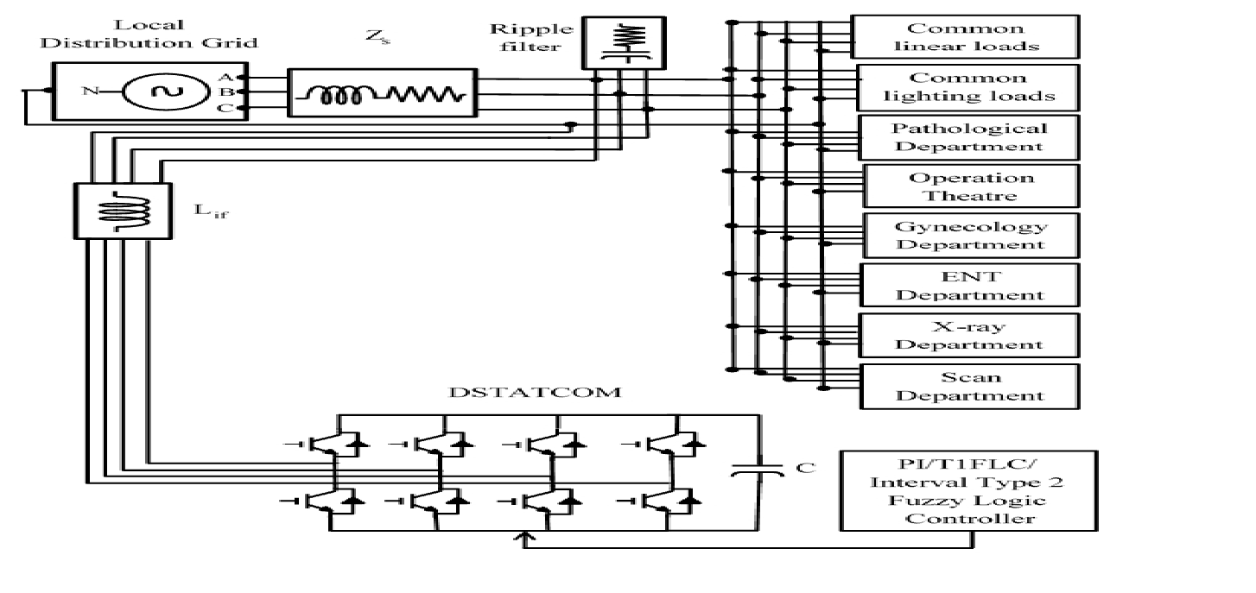
FIGURE 1. Proposed DSTATCOM configuration with interval Type-2 fuzzy
logic controller.
Connected in parallel with the LDG, a DSTATCOM helps with current harmonic repression, reactive energy reimbursement, neutral updating, and load balancing. The reference current generated by IT2FLC, the generator for DSTATCOM, removes the reactive component of the load. As a result, after removing the reactive terms, the originally constructed current component has just real terms. The DSTATCOM thereby lowers the reactive power load on the generator.
Load modeling is essential to the suggested work. There are four types of loads in the hospital: balanced, unbalanced, non-linear, and linear. Reversers are used when connecting multiple DC loads to one single AC supply. Issues with power quality are especially dangerous for hospital loads. The suggested method takes into account a variety of medical burdens [26]. In addition to the ear, nose,, gynaecological, X-ray, emergency unit, pathology, etc scan centers, there are many additional departments available. Peak burdens, critical loads, annual loads, or continuous use are some of the elements that affect the system's overall load.

4.2 Space Vector Pulse Width Modulation (SVPWM)

Reducing harmonic distortion in the output voltage and current is the aim of all modulation techniques. The technique of space vectors pulse width modulation will assist in achieving this desired outcome. The amplitude and frequency of the voltage reference vector are utilised in space vector PWM to adjust the fundamental voltage's magnitude and frequency. The space vector modulation of pulse width approach has gained popularity as the method of choice for controlling the voltage at the output from three phase inverters using voltage sources due to its many benefits.

The following methods can be used to apply the SVPWM technique:
Space vector modulation techniques include carrier-based modulation, decreased switching carrier-based modulation, sector selection-based modulation, and carrier-based modulation.

SVPM In order to address the vector method for PWM, or pulse width modulation, for the use of three-phase inverters, the Space Velocity Pulse Width Modulation (SVPWM) method was first developed. With less overall harmonic distortion, a larger voltage can be applied to the motor using this more advanced sine wave generation technology. Perhaps the best pulse width modulation technology for intermittent drive applications is Space Vector PWM (SVPWM), a sophisticated and computationally demanding method. The real part of load current, positive phase sequence, and fundamental frequency are provided by space vector pulse width modulation, which is controlled by gate triggering and has the ability to supply reactive power, harmonics, and unbalanced load compensation in this work. The top three transistors that provide power of a three-phase electric inverter switch in a unique way using the Space Velocity PWM (SVPWM) technology. It has been demonstrated to use dc input voltage more effectively and to produce less distortion caused by harmonics in the final voltages &/or winds applied to the three stages of an AC motor.

4.3 Fuzzy logic controller

The primary aim of this intelligent managed strategy is to equip system engineers with practical experience in implementing fuzzy controllers [12]. The engineers' controlled approach consists of a set of guidelines that are easy to follow by hand but challenging to apply when utilizing a traditional control strategy. Using heuristic knowledge to design nonlinear controllers is an easy way made possible by this approach.
The inputs in this suggested fuzzy controller system are errors (e), and changes in errors (∆e) produce the necessary control signal.The following modules make up FLC's design procedure:
1)Fuzzification 2
) Base of Fuzzy Rules
3) Defuzzification; and
4) Fuzzy Inference Engines (Decision Making Logic).
The four stages below are repeated in a cycle by a fuzzy controller. First, all variables representing pertinent aspects of the controlled environment are measured.

The Universal Discourse of Creess. To convey measurement uncertainty, these measurements are then fuzzy-ified (made into appropriate fuzzy sets). The inference engine (Decision Making Logic) uses the fuzzified measurements to assess the control rules kept in the fuzzy rule base. The evaluation yields an output fuzzy set, or many output fuzzy sets, based on the universe that contains potential actions. The Root Summation Square Method can be used to determine the output fuzzy set's degree of membership. In the last phase of the cycle, this fuzzy set is transformed into a clear (single) value that serves as the fuzzy set's best representation in some way (Defuzzification). The actions made by the controller that is fuzzy throughout individual control cycles are represented by the defuzzified value. We now create the different FLC components to tackle the power quality problem in the ensuing Sections. A fuzzy controller is created to produce the necessary control signal. It takes in the input signal from the system, processes the data in phases, and outputs the necessary results.

4.4 fuzzy inference system

The practice of applying fuzzy logic to map an input to an output is known as fuzzy inference. With fuzzy logic, two different kinds of systems for fuzzy inference can be put into practice. Two fuzzy inference systems are available for fuzzy logic implementation. The Mamdani and Sugeno types of inference systems have slightly different methods for determining their respective outputs.
4.5 Combining fuzzy rules:
It is possible for the fuzzy rule-based system to have several rules. the process of drawing general inferences from each rule's contribution of separately stated consequents fuzzy rules are referred to as aggregations of the rule or computation of the IF section of the rule, depending on which definition is used.

4.6 SVPWM Fuzzy Controller
In a VSC-based a microgrid the nonlinear SVPWM, or regulator fails to provide an appropriate current control method. Therefore, in order to achieve the control objectives and give SVPWM total control over the converter, a fuzzy-logic-based controllers is offered in the suggested method. Additionally flexible, the fuzzy-built SVPWM processor offers VSCs in micro-grids with irregular loads the performance they need.
a Z-source the VSC with an SVPWM controller based on fuzzy logic. This controller realizes programmed advanced exchange regulation over the converter's output against a fitting run through a delay by providing an acceptable decoupling current slip and compensating for it .

. 5. RESULTS AND DISCUSSION

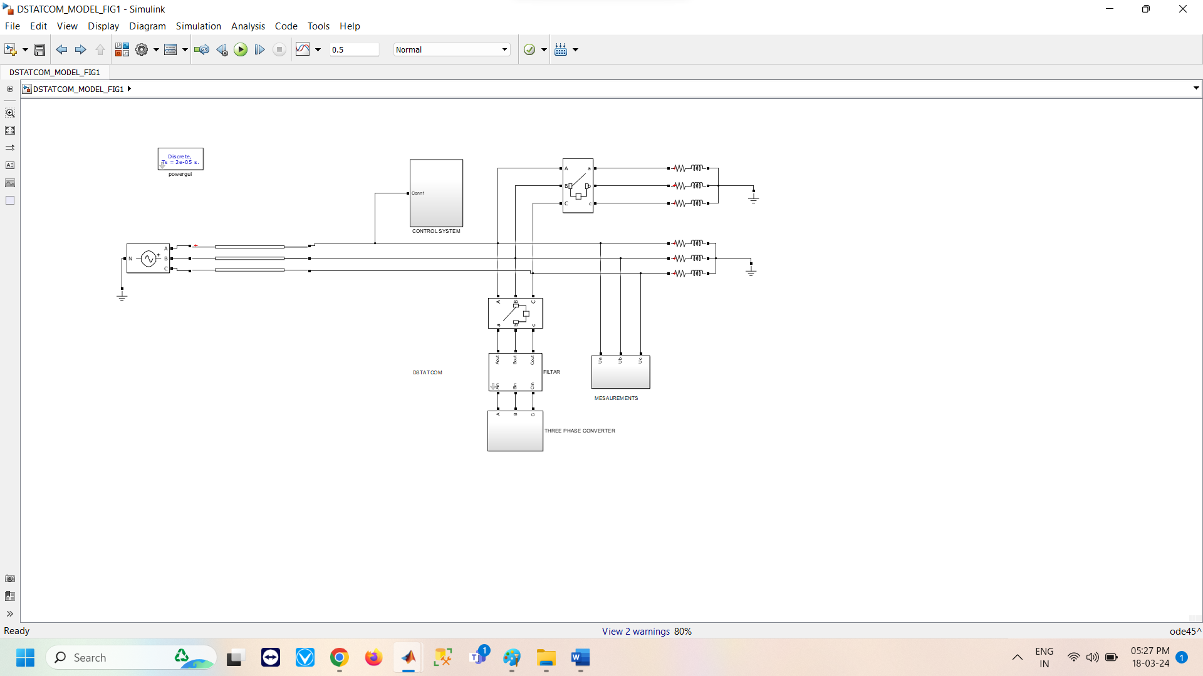
FIG 2: SIMULATION DIAGRAM
FUZZY WITH SV PWM TECHNIQUE
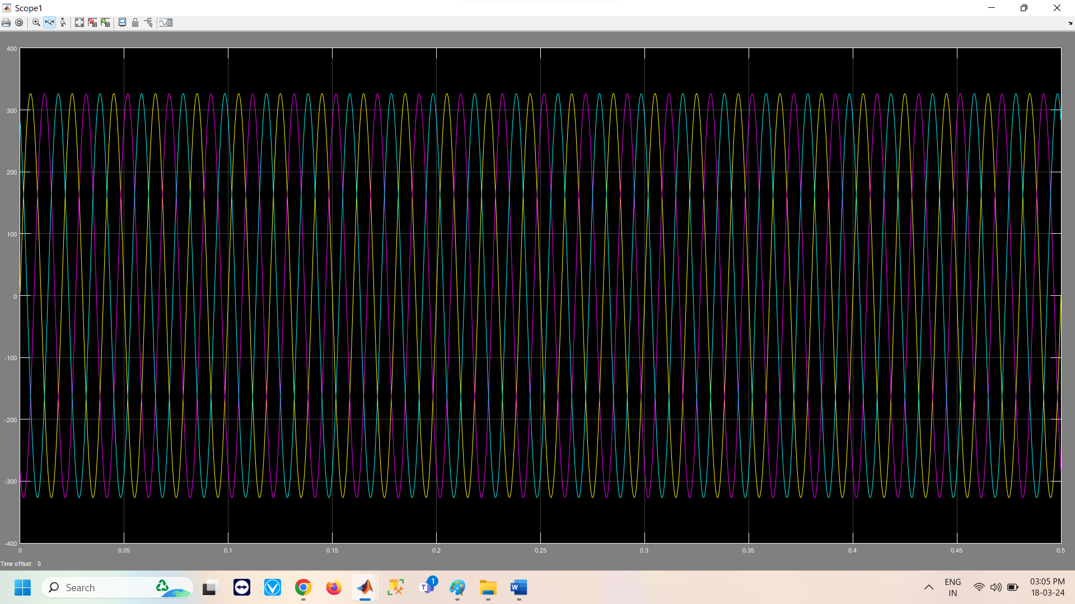
Fig 3: reference voltage generation
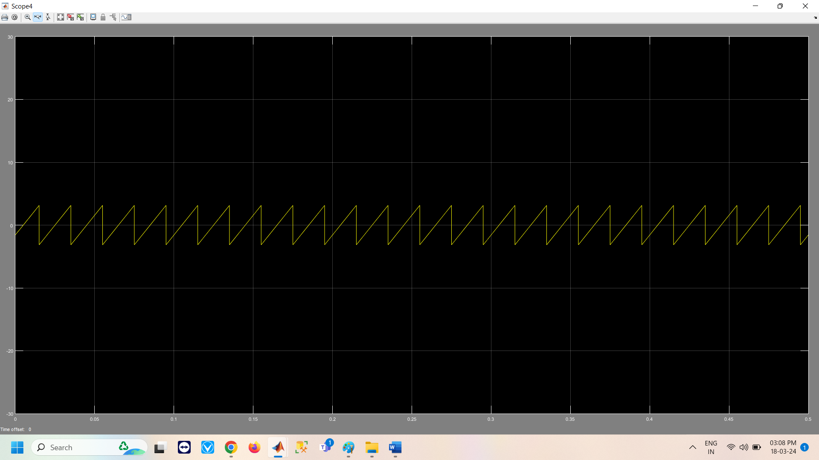
FIG 4: voltage under transformations of alpha beta.
The outcomes of utilizing the SVPWM smart fuzzy logic controllers are shown in the figures above. The outcomes of the performance is shown Fig. 3 shown in reference voltage generation and Fig. 4 shown voltage under transformations of alpha beta

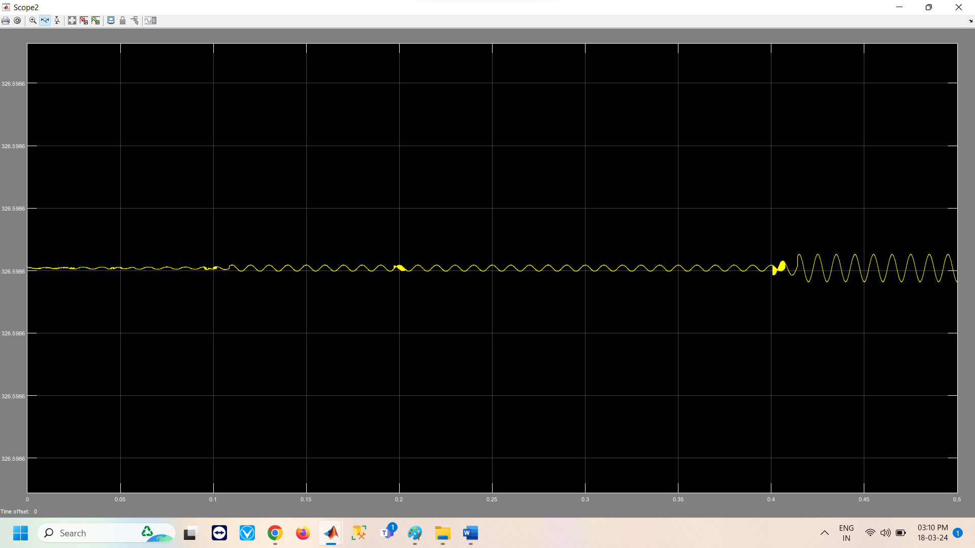
FIG 5: generated reference voltage magnitude
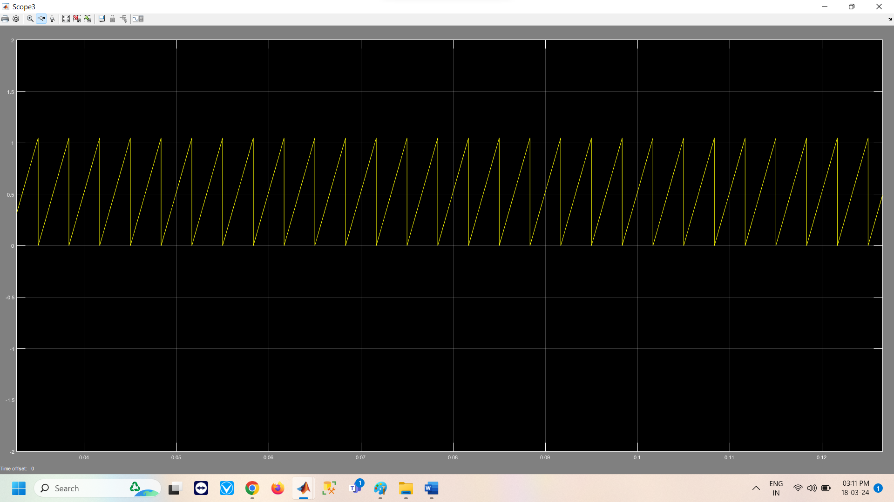
FIG 6: generated voltage angle
The outcomes of utilizing the SVPWM smart fuzzy logic controllers are shown in the figures above. The outcomes of the performance is shown Fig. 3 shows generated reference voltage magnitude and Fig. 4 shown generated voltage angle

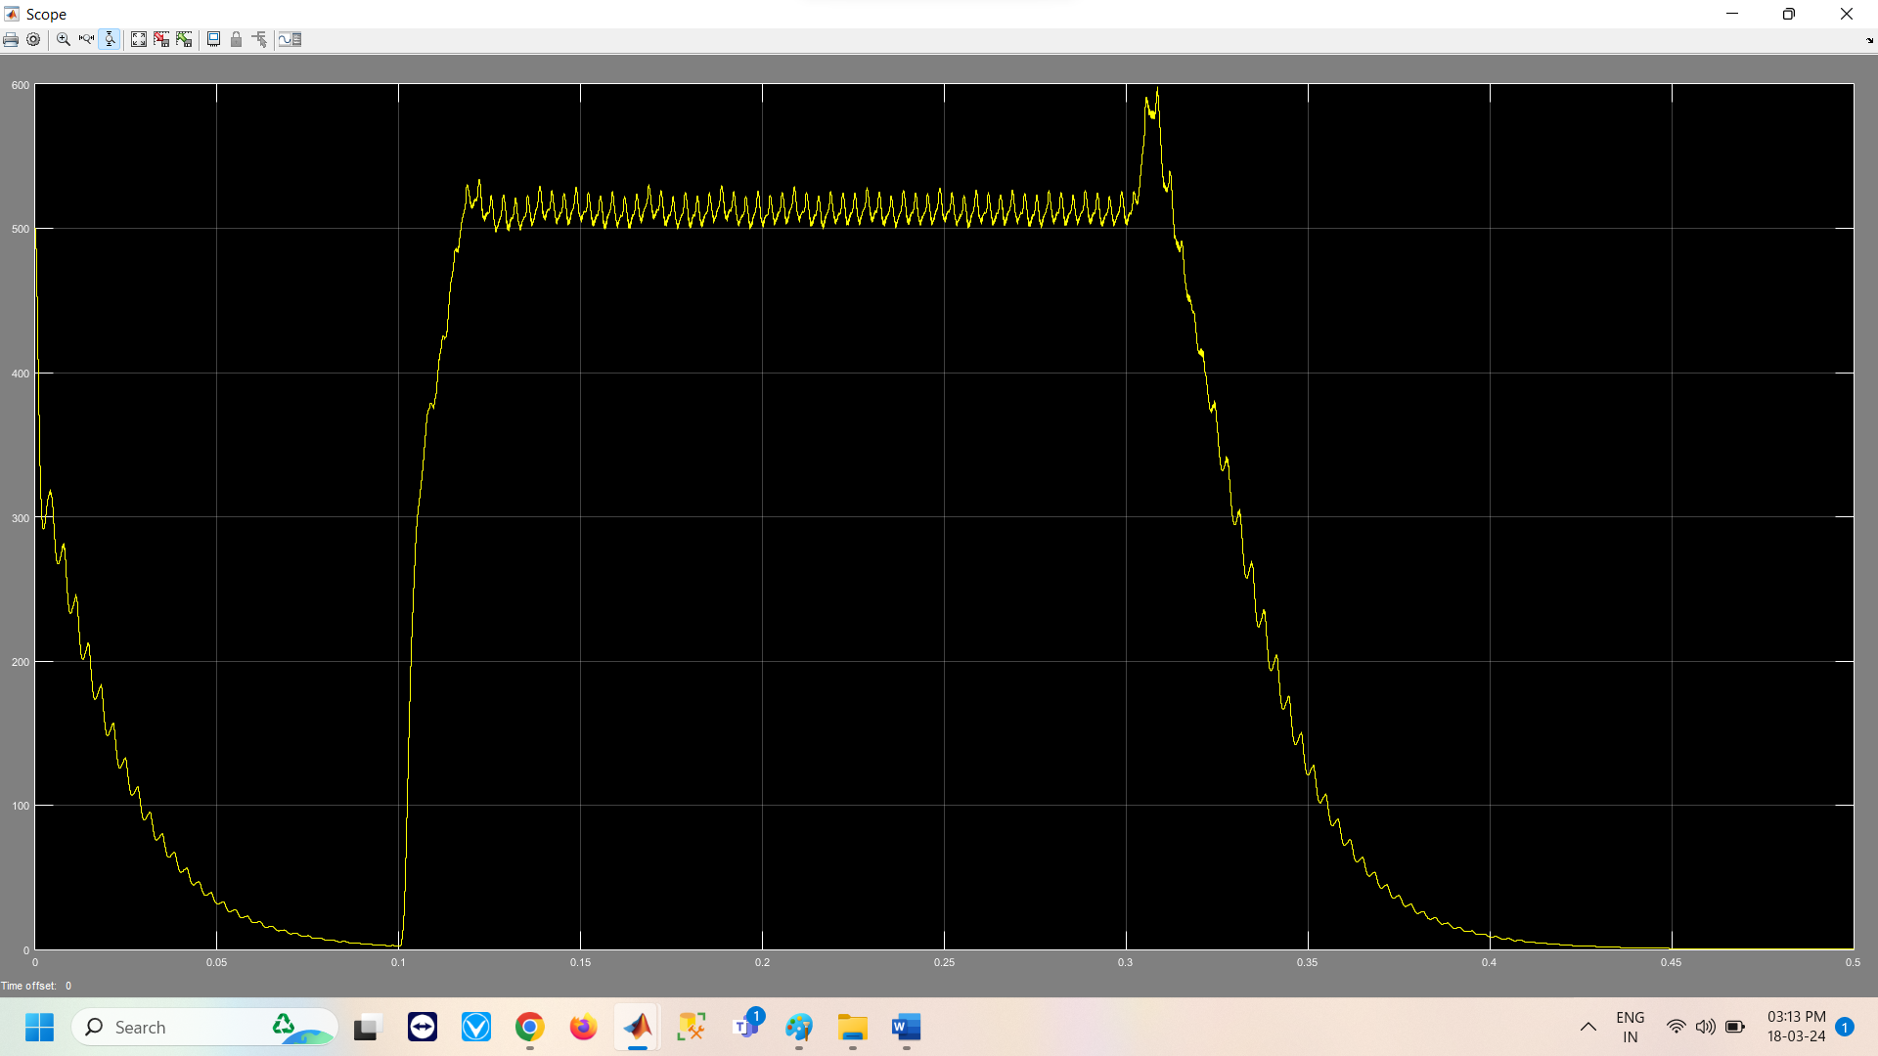
FIG 7: Vdc
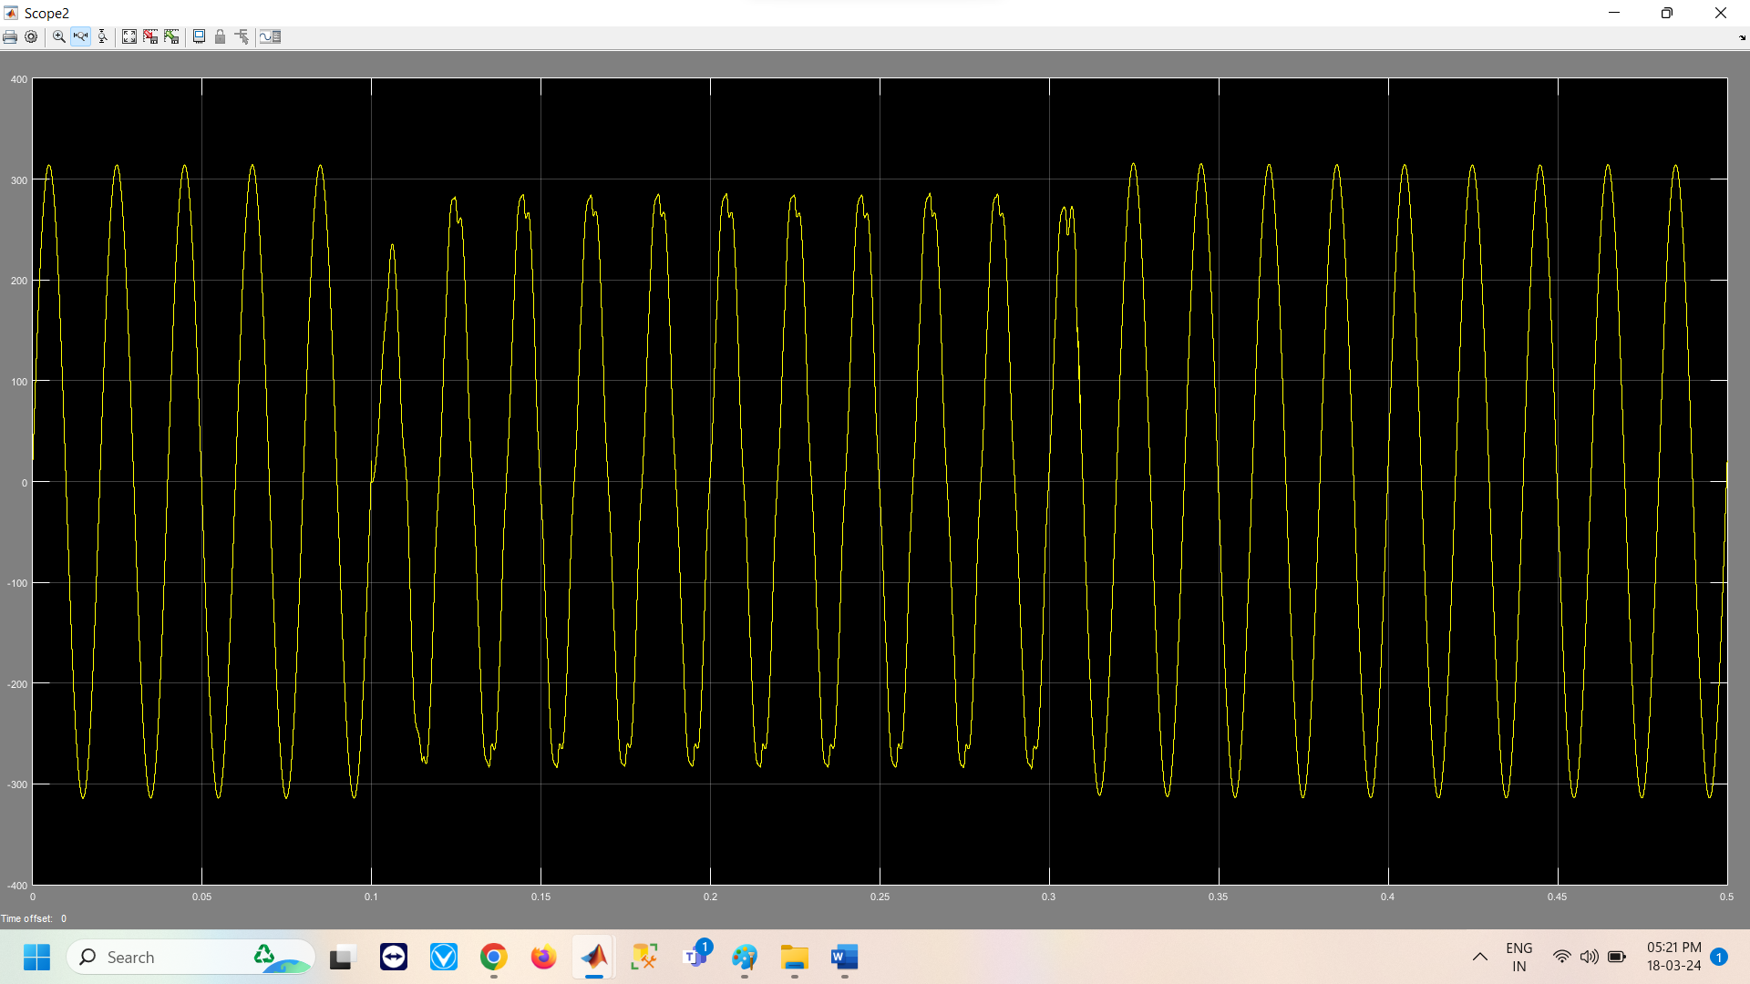
FIG 8: 1ST order harmonic
The outcomes of utilizing the SVPWM smart fuzzy logic controllers are shown in the figures above. The outcomes of the performance results is the Vdc waveform shown in Fig. 7. This Vdc output after compensation is more than the Fuzzy svpwm controller’s waveform shown in Fig. 10. 5st order harmonic
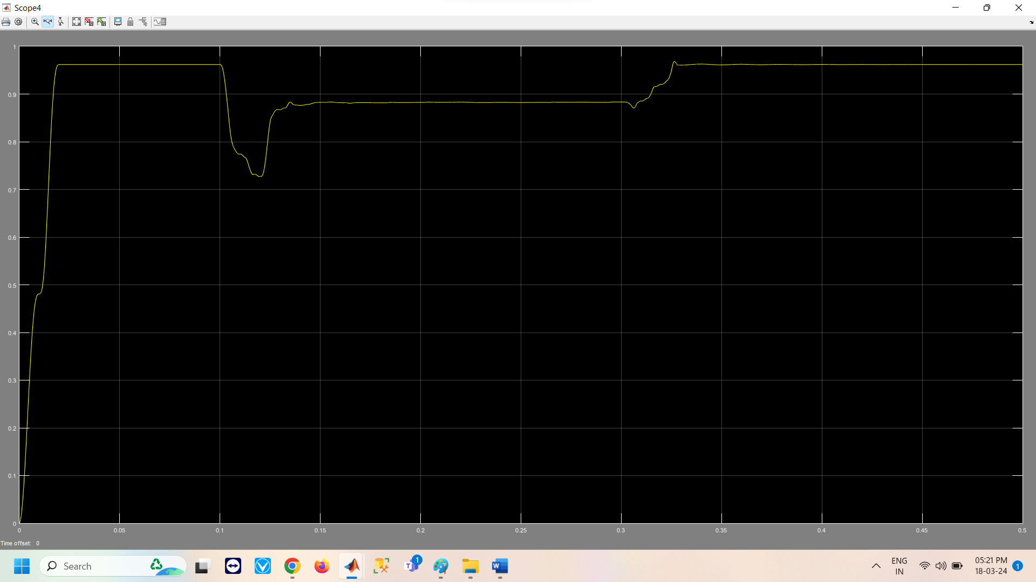
FIG 9: 3RD order harmonics
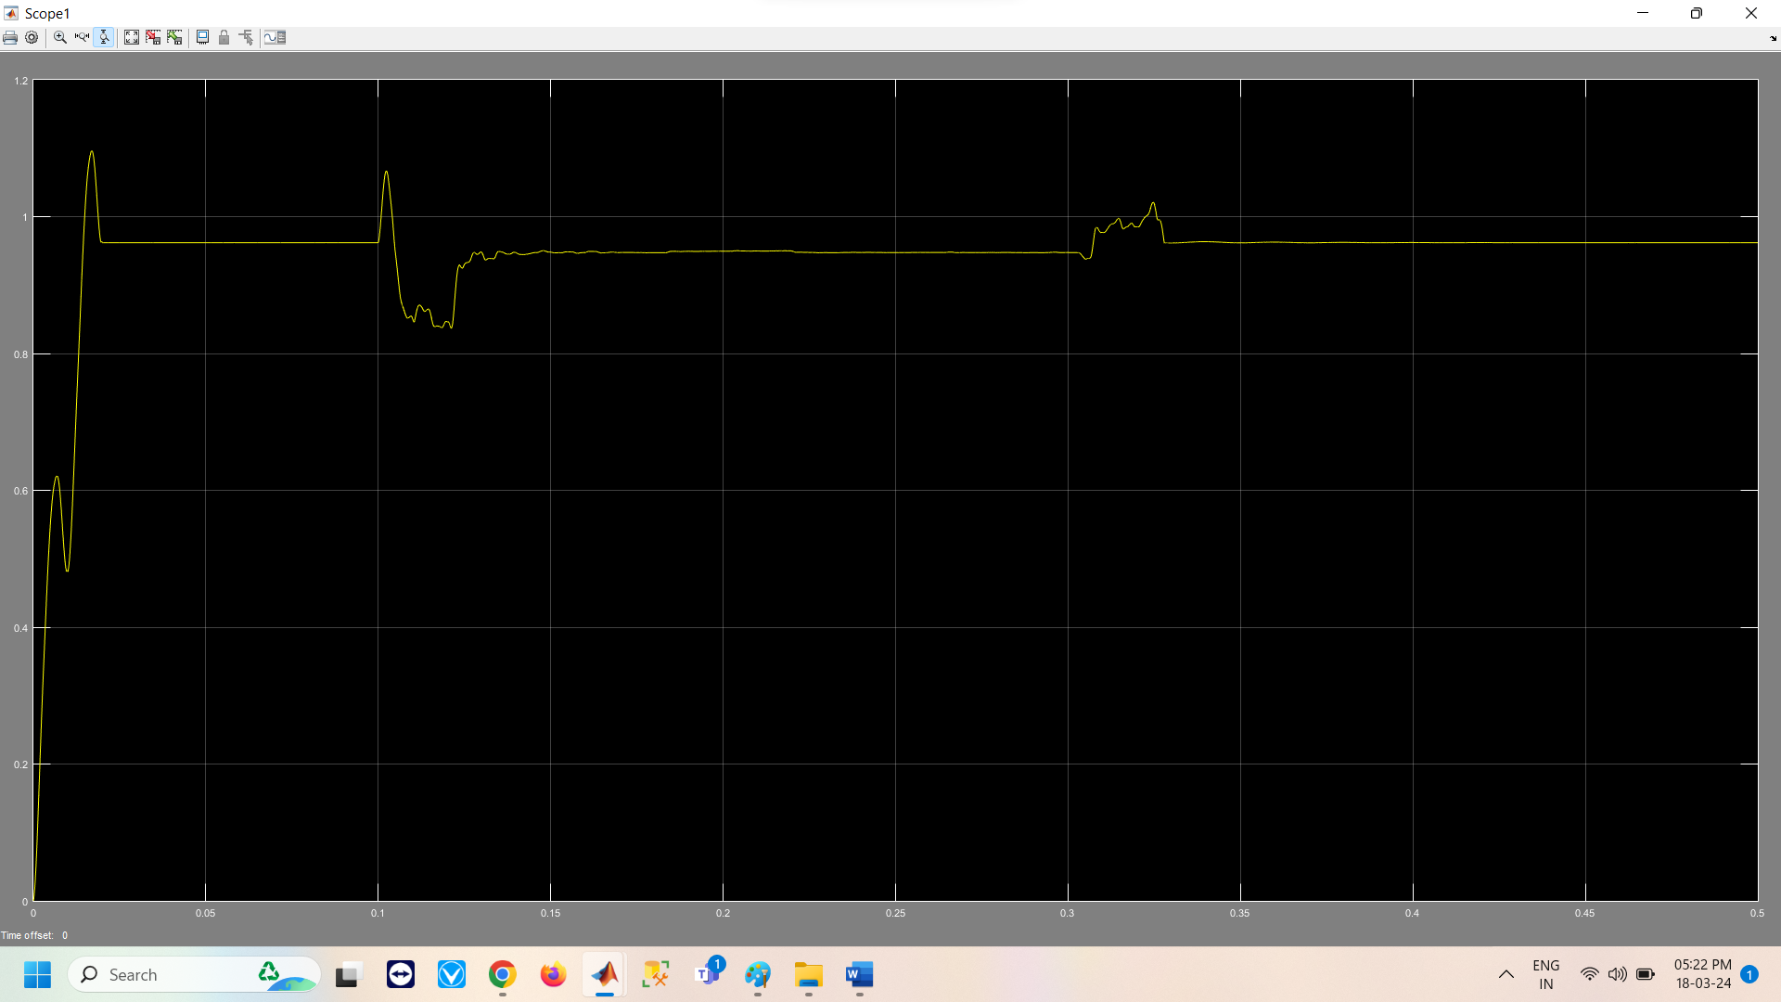
FIG 10: 5TH order harmonics
The outcomes of utilizing the SVPWM smart fuzzy logic controllers are shown in the figures above. The outcomes of the performance are shown in Fig. 9. From the 3rd order harmonic spectrum. and waveform shown in Fig. 10. 5st order harmonic.
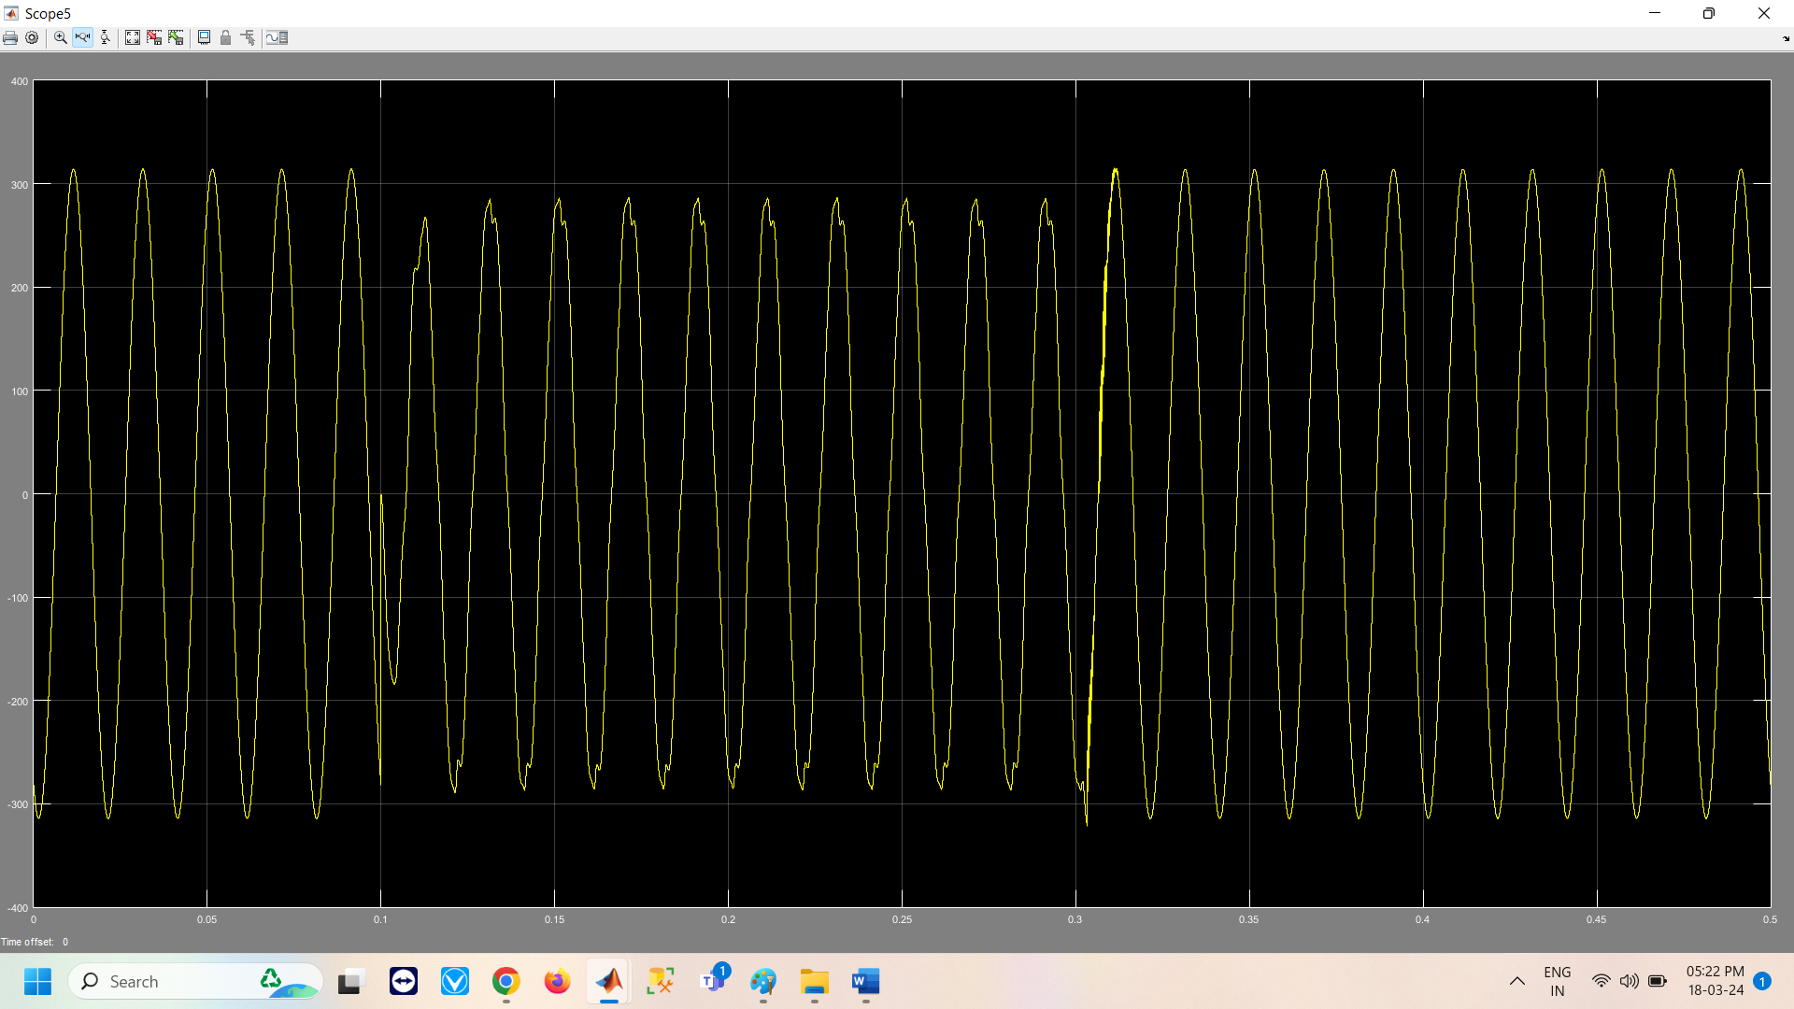
FIG 11: magnitude voltage of svpwm(ub)
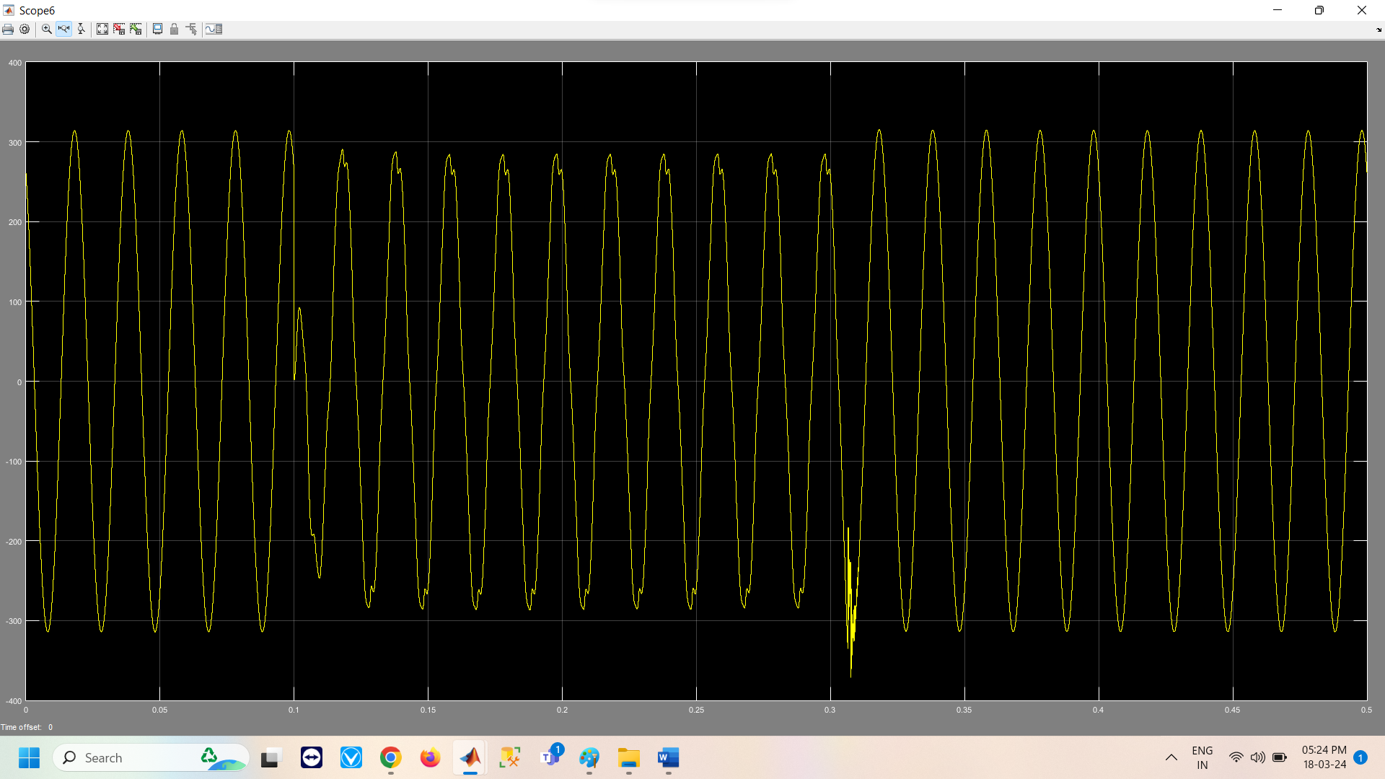
FIG 12: magnitude of voltage of svpwm (uc)
The outcomes of utilizing the SVPWM smart fuzzy logic controllers are shown in the figures above. The outcomes of the performance is shown fig. 11 shown in magnitude voltage of svpwm (ub) .fig.12.shown magnitude of voltage of svpwm (uc)
CONCLUSION

The Distribution Stable the DSTATCOM compensation is suggested as a solution for load balance, neutral present compensation, harmonics prevention, and reactive power imbalances. The current study seeks to improve the quality of electricity in the Municipal Distributed Grid by producing pulses of switching for IGBT switching in the DSTATCOM using an Intermittent Type-2 Fuzzy Logical Controller (IT2FLC) equipped with a the recursive Most Square (RLS) filter. In terms of harmonies mitigation, the suggested approach performs better than the Type 1 rationale controller and the Traditional PI controller. For effective implementation, MATLAB software is used to simulate the recommended system. However, this proposed method has not looked at the first order, and third order, or fifth order harmonics. Consequently, even if the system's efficiency will rise, we can say that the fuzzy and SV PWM technique is what's causing the system to perform better.
RECOMMENDATION
Feb 2022Mostafa Eidiani Mohammad Kargar A method based on a smart controller with PID-D-STATCOM was presented by the authors in Ref. to offer sufficient compensation and effectively aid in determining the ideal response time. In order to reduce the voltage sag, harmonic distortion, as well as the low power ratio in the distribution system, the authors provided a model linked to D-STATCOM with LCL passive filters.
Jul 2023Abdelnasser NafehAya Heikal The more external interference there is, the worse the PI controller's dynamic properties will get. As a result, other intelligent control techniques, including particle swarms, neural networks, fuzzy control, and others, have been developed in light of the shortcomings of 2PI controllers.
Mar 2023 Xuesong Zhou Weibao Zhong The Distribution of static synchronized compensation (D-STATCOM) direct and lateral blade currents are controlled by the Fuzz Proportional Integral (FPI) controller, which was created . It has a robust and nonlinear construction. In order to enhance a power system's dampening, this work offers a fuzzy logic management of the D-STATCOM.
Sep 2023 Mehdi Zangeneh Ebrahim Aghajari In thermal power plants, DSTATCOM is used to improve the electrical compensation for reactive power with a constant-speed induction motors . Two basic PI controllers were positioned at the shared coupling (PCC) point to provide a three-phase load voltage adjustment.
FUTURE SCOPS
- In order to control the space-vector PWM signal regulation for three-phase converters, this article proposes using fuzzy logic. Using a MATLAB Simulink, this technique coupled fuzzy logic command with conventional space-vector PWM. MATLAB is used to build the space vector PWM for the two-phase VSI. However, compared to traditional methods, fuzzy logic regulating still requires fewer intricate math operations; a computationally sophisticated control method is not necessary.
- To address issues with power quality, these mathematical models can be expanded to include specialized power devices into three-phase, four-wire distribution systems.
To get the appropriate response from DSTATCOM, various time domain or frequency domain approach-based control methods can be created.
- The control algorithms that have been created can be utilized in isolated energy-producing systems, including wind, solar, and micro-hydro based generation, to facilitate power transmission to loads, regulate voltage, and address power quality issues.
- It is also possible to expand the experimental validation of a grid-connected solar photovoltaic system using the suggested control algorithms for power transfer onto the grid and power quality issue correction.

DECLARATION CONFLICT OF INTEREST:
The authors declare that this manuscript has no conflict of interest with any other published source and has not been published previously (partly or in full). No data have been fabricated or manipulated to support our conclusions.
No funding is applicable and declaration for no financial Interest.
ACKNOWLEDGE
Acknowledgment The authors declare that they have no conflict of interest. The manuscript was written through contributions of all authors. All authors have given approval to the final version of the manuscript. The article has no research involving Human Participants and/or Animals. The author has no financial or proprietary interests in any material discussed in this article.
COMPLIANCE WITH ETHICAL STANDARDS:
Conflicts of Interest:
The authors declare that they have no conflict of interest. The manuscript was written through contributions of all authors. All authors have given approval to the final version of the manuscript.
Availability of data and material:
Not data and materials are available for this paper. Data sharing not applicable to this article as no datasets were generated or analyzed during the current study'
Ethical Approval:
The article has no research involving Human Participants and/or Animals
Competing Interest:
The author has no financial or proprietary interests in any material discussed in this article.
DECLARATIONS:
Funding:
No Funding is applicable.
Code availability:
The data and code can be given based on the request
Consent to Participate:
The manuscript was written through contributions of all authors. All authors have given approval to the final version of the manuscript.
Consent to Publish:
All authors have given approval to the final version of the manuscript for publication.

REFERENCES
- R. E. Agency. ‘IRENA (2022), Renewable Energy Statistics 2022, The International Renewable Energy Agency, Abu Dhabi’, Irena, no. March 2021, 2021
- Ravi, T. & Kumar, K. S. Detection and classification of power quality disturbances using stock well transform and improved grey wolf optimization-based kernel extreme learning machine. IEEE Access, 2023
- Silva-Leon, J., Cioncolini, A., Nabawy, M. R. A., Revell, A. & Kennaugh, A. Simultaneous wind and solar energy harvesting with inverted flags. Appl
- Energy https://doi.org/10.1016/j.apenergy.2019.01.246 (2023).
- Keeley, A. R. & Matsumoto, K. ‘Investors’ perspective on determinants of foreign direct investment in wind and solar energy in developing economies: Review and expert opinions. J. Clean. Prod. https://doi.org/10.1016/j.jclepro.2017.12.154 (2022).
- .Al-Ghussain, L. et al. A demand-supply matching-based approach for mapping renewable resources towards 100% renewable grids in 2050. IEEE Access 9, 58634–58651 (2021)
- Fathy, A., Alharbi, A. G., Alshammari, S. & Hasanien, H. M. Archimedes optimization algorithm based maximum power point tracker for wind energy generation system. Ain Shams Eng. J. https://doi.org/10.1016/j.asej.2021.06.032 (2022).
- Basit, M. A., Dilshad, S., Badar, R. & ur Rehman, S. M. Limitations, challenges, and solution approaches in grid-connected renewable energy systems. Int. J. Energy Res. 44(6), 4132–4162 (2020).
- Ashok Kumar, L. & Indragandhi, V. Power quality improvement of grid-connected wind energy system using facts devices. Int. J. Ambient Energy 41(6), 631–640 (2020).
- Ahmed, S. D., Al-Ismail, F. S. M., Shafiullah, M., Al-Sulaiman, F. A. & El-Amin, I. M. Grid integration challenges of wind energy: A review. IEEE Access 8, 10857–10878 (2020).
- Aditya, T., Raj, R. D. A. & Shinde, M. R. Power quality analysis, challenges and feasible solutions of 90 kWp grid-integrated PV system. In 2020 International Conference on Emerging Trends in Information Technology and Engineering (ic-ETITE), pp. 1–5, 2020.
- Magesh, T., Devi, G. & Lakshmanan, T. Improving the performance of grid connected wind generator with a PI control scheme based on the metaheuristic golden eagle optimization algorithm. Electr. Power Syst. Res. 214, 108944 (2023).
- Magesh, T., Devi, G. & Lakshmanan, T. Improving the performance of grid connected wind generator with a PI control scheme based on the metaheuristic golden eagle optimization algorithm. Electr. Power Syst. Res. 214, 108944 (2023).
- Rawa, M., Mohamed, H. N., Al-Turki, Y., Sedraoui, K. & Ibrahim, A. M. Dynamic voltage restorer under different grid operating conditions for power quality enhancement with the deployment of a PI controller using gorilla troops algorithm. Ain Shams Eng. J. 14(10), 102172 (2023).Feyzi, M., Roo
- zbehani, S. & S. G. Liasi, ‘Low Voltage Ride Through Improvement of Machine Side and Grid Side Converters of PMSG-Wind Turbine Based on SMC’, in 2022 13th Power Electronics, Drive Systems, and Technologies Conference (PEDSTC), 2022, pp. 251–257.
- Naderi, S. B., Negnevitsky, M., Jalilian, A., Hagh, M. T. & Muttaqi, K. M. Low voltage ride-through enhancement of DFIG-based wind turbine using DC link switchable resistive type fault current limiter. Int. J. Electr. Power Energy Syst. 86, 104–119 (2017).
- Li, J., Zhang, Z. & Yang, X. A novel model predictive control strategy of D-PMSG wind turbine systems for LVRT based on two-state unloading resistance and super capacitor. In Journal of Physics: Conference Series, p. 12048, 2023.
- Islam, M. M., Muttaqi, K. M. & Sutanto, D. A novel saturated amorphous alloy core based fault current limiter for improving the low voltage ride through capability of doubly-fed induction generator based wind turbines. IEEE Trans. Ind. Appl. 57(3), 2023–2034 (2021).
- Song, Y. et al. A Q-learning based robust MPC method for DFIG to suppress the rotor overcurrent. Int. J. Electr. Power Energy Syst. 141, 108106 (2022)
- Hiremath, R. & Moger, T. Modified super twisting algorithm based sliding mode control for LVRT enhancement of DFIG driven wind system. Energy Rep. 8, 3600–3613 (2022).
- Gupta, S., Verma, A., Singh, B., Garg, R. & Singh, A. AES-FLL control of RES powered microgrid for power quality improvement with synchronization control. Electr. Power Syst. Res. 203, 107681 (2022)
- Watil, A., El Magri, A., Lajouad, R., Raihani, A. & Giri, F. Multi-mode control strategy for a stand-alone wind energy conversion system with battery energy storage. J. Energy Stor. 51, 104481 (2022).
- Krishna, D., Sasikala, M. & Kiranmayi, R. FOPI and FOFL controller based UPQC for mitigation of power quality problems in distribution power system. J. Electr. Eng. Technol. 17(3), 1543–1554 (2022)
- Krishna, D., Sasikala, M. & Ganesh, V. Adaptive FLC-based UPQC in distribution power systems for power quality problems. Int. J. Ambient Energy 43(1), 1719–1729 (2022).
- Ahilan, T. et al. Wind connected distribution system with intelligent controller based compensators for power quality issues mitigation. Electr. Power Syst. Res. 217, 109103 (2023).
- Fomba, A. J. S., Hermawan, H., Andromeda, T., Facta, M. & Setiawan, I. Simulation of grid-tied photovoltaic system based on solar irradiance and temperature data in Semarang. In E3S Web of Conferences, 2019.
- Khandelwal, A. & Neema, P. State of art for power quality issues in PV grid connected system. In 2019 International Conference on Nascent Technologies in Engineering, ICNTE 2019—Proceedings, 2019.
- Bahri, H., Oualifi, K., Aboulfatah, M., Guisser, M., Adekanle, O. S. & El Malah, M. Nonlinear observer-based control for three phase grid connected photovoltaic system. In 2019 International Conference on Wireless Technologies, Embedded and Intelligent Systems, WITS 2019, 2019.
- Hamdan, I., Maghraby, A. & Noureldeen, O. Stability improvement and control of grid-connected photovoltaic system during faults using supercapacitor. SN Appl. Sci. https://doi.org/10.1007/s42452-019-1743-2 (2019).
- Gabr, W. I. & Salem, W. A. Impact of grid connected photovoltaic system on total harmonics distortion (THD) of low voltage distribution network: A case study. In 2020 20th International Middle East Power Systems Conference, MEPCON 2022—Proceedings, 2023. https://doi.org/10.1109/MEPCON.2018.863521

